Contents

3.1 Analysis of the problem 2
3.1.1 Problem identification 2
3.1.2 Stakeholders 3
3.1.3 Research the problem 4
3.1.4 Specify the proposed solution 12
3.2 Design of the solution 14
3.2.1 Decompose the problem 14
3.2.2 Describe the solution 16
3.3.3 Describe the approach to testing 28
3.3 Developing the solution 31
Iterative development process & testing 31

3.1 Analysis of the problem

3.1.1 Problem identification

The problem:
Sixth form students work hard throughout the year in order to achieve good grades in their A levels. Many of them like to play videogames to relax. However, these videogames are seldom beneficial to their education. It would be better to have games that are linked to the subjects studied at school as this could lead to improved academic performance.
Many students in my year 12 Physics class struggled with kinematics, especially projectile motion. Therefore, I will create a game which involves users firing projectiles at objects. The game will require mathematical and scientific knowledge as users will need to calculate the path the projectile needs to take. For example, they may need to consider variables such as air resistance and gravity as these may change the motion of the projectile. The game will have many levels are get progressively harder as the difficulty of the calculations required increases.

Why the problem is amenable to a computational approach:
This problem is amenable to a computational approach for two main reasons. The first reason is because the solution will use algorithms to calculate the projectile path whilst taking in user outputs. The second reason is because the solution will output the motion of the projectile onto the screen using animations and graphics.

Why the problem is solvable by computational methods:
There are several computational methods that can be used to solve this problem.
Problem recognition:
The overall problem is being able to accurately animate the path that a projectile will take. The underlying problem is calculating the path that the projectile will take by taking into account the variables that may affect its motion. When the underlying problem is overcome, the rest of the solution is simply applying the information relating the motion of the projectile to the animation so that the user can see what happens.

Problem decomposition:
This problem can be decomposed into smaller steps.
For each level in the game:
- Set up projectile and target at certain distances and angles away from each other.
- Set up the variables such as terrain, air resistance, gravity.
- Allow the user to input the speed and angle of release of the projectile
- Use mathematical calculations to work out the motion of the projectile and see if it hits the target.
- Animate this, making sure to account for the scale of the screen and other potential computer configurations.

Use of divide and conquer:
The overall problem can be divided into these smaller steps. Each of these steps can then be conquered individually and combined together to make the final program. Using this method means that the complex overall problem is split into more manageable smaller problems which makes development easier.

3.1.2 Stakeholders

My solution will be of interest to two different groups of people.
The first group is comprised of those that study Physics or Mathematics at A level and struggle with the topic of projectile motion. For them, my solution will be of academic interest as it could help improve their understanding of the topic. They would be most interested in the mathematical and scientific calculations behind the projectile motion.
The second group is comprised of those that have an interest in videogames but also want to be intellectually challenged by the game. For them, my solution will be for personal enjoyment. They would be most interested in the playability and the graphics of my solution.
My main stakeholder will be David Kuc. He studies Mathematics and Physics at A level so my solution will benefit him by allowing him to recap projectile motion. He also enjoys playing computer games, so the solution will benefit him through increasing his personal enjoyment.
Therefore, he will be able to represent to two main groups of people who would have an interest in my solution.

3.1.3 Research the problem

Existing similar solution 1 – ‘Angry Birds 2’:
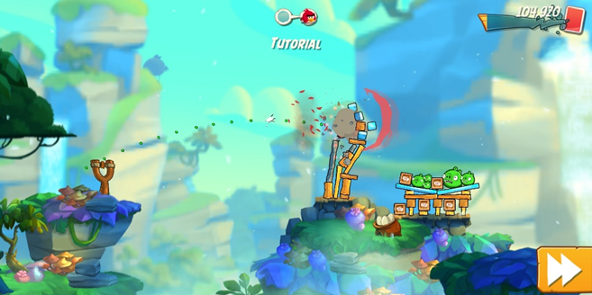

‘Angry Birds 2’ is a game where players use a slingshot to launch birds at nearby targets. The game can be played on multiple platforms but I tested the game on a mobile phone. The slingshot is directed using hand movement on the screen. The game shows the path that the bird will take using green dots. The game has music in the background. There are multiple levels and the difficulty increases as you progress.
There are many features of the game that I like and could possibly apply to my solution:
- Shows the user the path that the bird will take.
- Graphics are detailed and in 3d.
- The slingshot is easy to control and adjust using hand movement.
- There are rewards for hitting targets.

Existing similar solution 2 – ‘PhET Projectile Motion’:
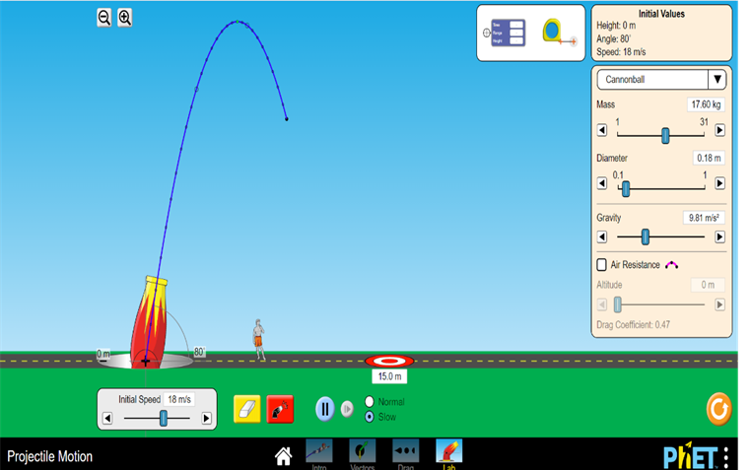
‘PhET Projectile Motion’ is a simulator where you can fire projectiles. It is not a game but is instead used for educational purposes.
There are several features of the simulator that I like and can apply to my solution:
- Shows the path that the projectile takes using a series of blue dots connected together with a blue line.
- Angle that the projectile is fired at is easily adjustable through mouse movement.
- Speed of the projectile is easily changed through a slider bar.
- Can change the speed of the animation.

Existing similar solution 3 – ‘Galileo and Einstein Projectile Motion’:

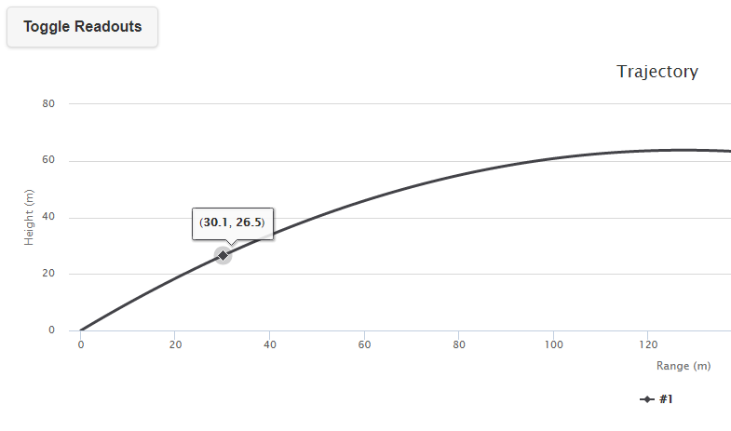
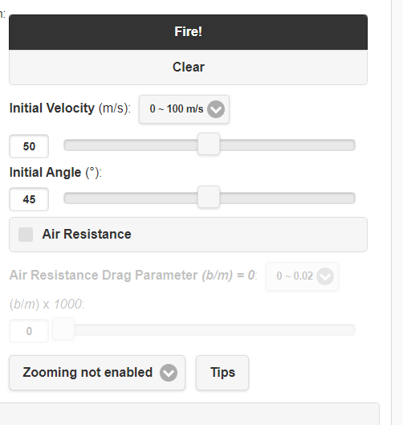

‘Galileo and Einstein Projectile Motion’ is a simulator where you can plot the paths of projectiles . It is not a game but is instead used for educational purposes.
There are several features of the simulator that I like and can apply to my solution:
- Shows the path that the projectile takes using a series of blue dots connected together with a blue line.
- Angle that the projectile is fired at is easily adjustable through mouse movement.
- Speed of the projectile is easily changed through a slider bar.
- Can change the speed of the animation.

Survey:
I conducted of stakeholders. I decided to ask the following questions to find out he general features that my users wanted from my solution and their experience of any similar solutions.
1. How big should the game screen be?
2. How would you like to fire the projectile?
3. Do you want the game to save your progress?
4. What would be your preferred method of playing the game?
5. What features would you like the game to contain?
6. If you have ever played a similar game, what features did you like?
7. Would you like music in the game and if so, what type?
8. Any other comments

Q1: How big should the game screen be?
- Full screen [42.86%]
- Window [57.14%]
Analysis: The majority of stakeholders prefer a window.

Q2: How would you like to fire the projectile?
- Entering values manually [42.86%]
- Slider bar [57.14%]
Analysis: The majority of stakeholders prefer a slider bar system.

Q3: Do you want the game to save your progress?
- Yes [85.71%]
- No [14.29%]
Analysis: Overwhelming consensus is for the game to save user progress.

Q4: What would be your preferred method of playing the game?
- Computer/ Laptop [85.71%]
- Mobile phone [14.29%]
- Other [0%]
Analysis: Overwhelming consensus is for the game to be computer/ laptop based.

Q5: What features would you like the game to contain?
- It should be fun, not too ugly and not boring or too challenging. It should have different levels or difficulties.
- Some kind of goal - i.e. a reason to play the game. Maybe make an adventure mode or something with different levels of difficulty as you progress.
- Choice of colour for the projectile
- Good graphics.
- Projectile skins.
- Easy controls.
Analysis: Wide range of opinions received. Most stakeholders want some kind of customisability.

Q6: If you have ever played a similar game, what features did you like?
- Angry birds: it had intuitive controls and was fun.
- The game would report back on how close/far I was.
- Angry birds had fun physics and structures to destroy. Was pretty satisfying.
- The sound when the object hits the target or misses it.
- Chain reactions objects, like hit an explosive barrel to cause a greater effect.
- Being able to aim easily.
Analysis: Wide range of opinions received. Some stakeholders played ‘Angry Birds’ which I had already analysed as an existing solution. Other interesting features were mentioned.

Q7: Would you like music in the game and if so, what type?
- Yes. Ambient or relaxing music. It can be fast paced energetic music if it suits the game, but it shouldn't be too distracting. There should always be an in-game option to turn music and sound effects off.
- Yes. Any kind is fine. If it's not too complex, making the option to switch between different tracks might be nice.
- Yes. Instrumental music.
- Yes. Happy uplifting stuff.
- Yes. Upbeat music.
- Yes. Chiptune could be cool
- Yes. Non distracting.
Analysis: All stakeholders would like music. However, there is no consensus on the type.

Interview with main stakeholder:
Once I had the results of the survey, I decided to conduct an interview with my main stakeholder. I asked him (David Kuc) the same questions but was looking to gain more detailed and specific answers, especially where the opinions from my survey had been more unclear.

Q1: How big should the game screen be?
I would like it to be a window. There are a few reasons why.
Primarily, by using a screen, the user can easily switch between the game and other applications at will without the hassle of the processor having to refocus other tasks.
Also, a screen can be resized to the desirable size and resolution by the user.
Overall, a screen is more beneficial for using other applications simultaneously which is why I prefer it.
The only downside to a screen is that the CPU and GPU are also being used by other processes so you may experience lag or limited FPS. Though given that this game is unlikely to use excessive amounts of processing power, it isn't much of an issue.
Analysis: The main stakeholder has a clear preference for a window.

Q2: How would you like to fire the projectile?
A slider bar system would be preferable. This is because it allows the user to adjust the values without having to type them in.
This decreases the accuracy of the number selection; however, it is a lot easier to slide a bar than manually type out a value.
For this game, it is unlikely that the user will need to be too specific about their values, which is why I'd recommend focusing on usability over accuracy.
Analysis: The main stakeholder has a clear preference for a slider bar system.

Q3: Do you want the game to save your progress?
Yes, definitely.
Analysis: The main stakeholder would like the game to save user progress.

Q4: What would be your preferred method of playing the game?
I would like to play the game on my laptop.
Analysis: The main stakeholder would like the game to be computer/laptop based.

Q5: What features would you like the game to contain?
I think that generally, users like customisability. You shouldn’t restrict the users by using set systems for everything, but instead try to allow for options and variety wherever possible.
The more that a user can customise the game; the more likely they are to do so. And if a person spends a long time setting something up, they are unlikely to give up all of that effort easily, so it’s another way of drawing people in and having them keep playing.
Analysis: This answer is particularly helpful. It shows that I should give the users as much flexibility and control as possible.

Q6: If you have ever played a similar game, what features did you like?
I have played Wii bowling and Angry Birds. However, I have played a variety of other games where you need to complete similar objectives as side tasks or minigames.
I liked having to avoid obstacles, and having other external elements act on the system like wind and gravity.
Analysis: This answer gives me some ideas of the successful features of similar games.

Q7: Would you like music in the game and if so, what type?
Yes, but the music should depend on the theme of the game. For example, if the setting is in space, then the audio should complement that setting.
I’d recommend creating a variety of themes, which can either be toggled by the player, appear randomly, or occur for certain predetermined levels, where the background, sprites and music all change and are all linked together.
For example, if there is a nature theme where the background is a forest, the sprites should be natural colours and the music should be like something from ‘The Hobbit’.
Analysis: The main stakeholder would like the music to represent the ‘mood’ of the game.
Essential features of the computational solution:
From conducting the survey and the interview, I was able to find out what the essential features of my solution will be.
Feature | Justification
Game screen will be windowed | Most stakeholders would prefer a windowed screen compared to a full screen.
Projectile will be fired using a slider bar | Most stakeholders would prefer a slider bar system compared to a manual entry system.
Game will save user progress | Most stakeholders would prefer the game to save their progress.
Users will be able to register / login | This is necessary in order for the game to save user progress.
Game will be playable on a computer / laptop | Most stakeholders would prefer the game to be playable on a computer / laptop.
Game will have several levels which increase in complexity | This provides a purpose to the game.
Users will be able to toggle music between on and off | This allows the user to have more control over the game.

Limitations of the solution:
The main limitation of my solution will be the precision of the projection motion calculation. This is because the calculation will involve imprecise values. For example, a slider bar system will limit the precision to which the user can specify the speed of the projectile. This will mean that the calculations carried out by the program may result in values that are slightly different to what the user intended.
To fix this limitation, I will include a margin of error in all calculations meaning that slight variations in values will be accepted. This will make it easier to users to hit the target with their projectile.

3.1.4 Specify the proposed solution

The solution requirements were agreed with my main stakeholder, David Kuc.
Hardware and software requirements:
Requirement | Justification | Type
Windows/Linux/UNIX/Mac OS X Operating System | These operating systems are supported by Python. | Software
Python with Tkinter & Pygame | Needed to run the program. | Software
Computer with keyboard, mouse and monitor | Needed to use the program. | Hardware

Design requirements:
Requirement | Explanation | Justification
Game will be windowed. | Allow users to have other programs open whilst playing the game. | This was a key stakeholder requirement.
User instructions | Shows the users how to play the game and use the software. | This will improve the user experience.
Lightweight design | The game design should be simple and easy to follow. | This will improve the user experience.

Functionality requirements:
Requirement | Explanation | Justification
Projectile fired using a slider bar system. | Allows users to adjust the flight of the projectile. | This was a key stakeholder requirement.
Game progress saved | Allows users to come back to the level they have got to. | This was a key stakeholder requirement.
Login/ registration system – linked to a database | Allows users to create their own account which is linked to their game progress. | This will allow game progress to be saved.
Settings menu | Allows users to adjust settings e.g. music | No general stakeholder consensus on the type of music so will give users options to toggle music on or off.
Unique game levels | Each game level is different as the settings and variables that need to be taken into account will change. | Requested by a stakeholder. Gives a purpose to the game.

Success criteria:
The following success criteria was generated through the survey and interview with my main stakeholder.
Criteria Number | Criteria | How it will be evidenced
1 | The game will be windowed | Screenshot of the window
2 | User instructions will be provided | Screenshot of the game window
3 | The game design will be lightweight | Screenshot of the game window
4 | Use of slider bar system to fire projectile | Screenshot of the game window
5 | Progress of user in the game is saved | Screenshot of the game window + coding + testing
6 | A login/ registration system for users | Screenshot of the game window + coding + testing
7 | User details will be stored in a database | Coding + testing
8 | Settings menu with option to toggle music | Screenshot of the game window
9 | Each game level will be unique e.g. have different values of gravity | Screenshot of the game window + coding

3.2 Design of the solution

3.2.1 Decompose the problem

In this section, I split my solution into smaller parts. By doing this, I make my project easier to program and manage. This is because smaller sections can be completed independently and then combined to create the finalised solution.
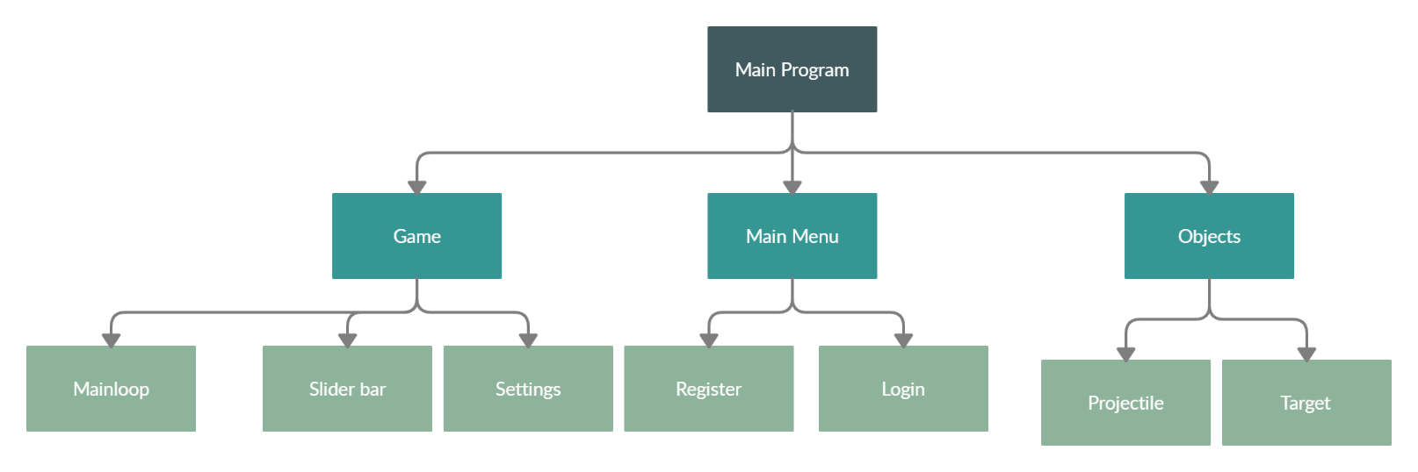

Description of main modules:
Main Menu:
This module will initialise the user interface. It will be a window which will allow the user to choose whether to register or login.

Game:
Initialises the game and game window.

Objects:
Initialises the objects – projectile & target.

Mainloop:
Constantly update the projectile position on the screen and check if there has been any collisions.

Slider bar:
Initialises two slider bars. One for the speed and one for the angle.

Settings:
Button which can be pressed to toggle music or exit the game.

Register:
Window with a username and password field for new users.

Login:
Window with a username and password field for returning users.

Projectile:
Object that will be fired by the user.

Target:
Object that the user will try to hit.

3.2.2 Describe the solution

Structure of the solution:
My solution will be structured modularly. As shown earlier, I will use decomposition to break down the overall solution into smaller and more manageable modules which will be developed indepdently.
There are several advantages to structuring my solution in this way.
Firstly, solving smaller problems will enable faster development as each individual module can be programmed and then all of the modules can be brought together to make the final solution. For example, I can indepdently develop the module for the slider bar system, and then later add it to the overall solution.
In addition, a modular approach makes testing easier. This is because each module can be tested indepently meaning that any errors can be isolated to each module. For example, if there is an error in my program, I would be able to narrow it down to a specific module e.g. mainloop module, and then solve it without inadvertedly spoiling other parts of the program.
A modular approach will also help the program to be more easily read. This is because there will be clearly defined subroutines meaning the flow of the program is easy to follow.
Overall, the are several advantages to using a modular approach and therefore I will apply this approach to my solution.

Algorithms:
Calculate projectile path: This algorithm will take in account the different variables that affect projectile motion and calculate it’s position at every point in time.
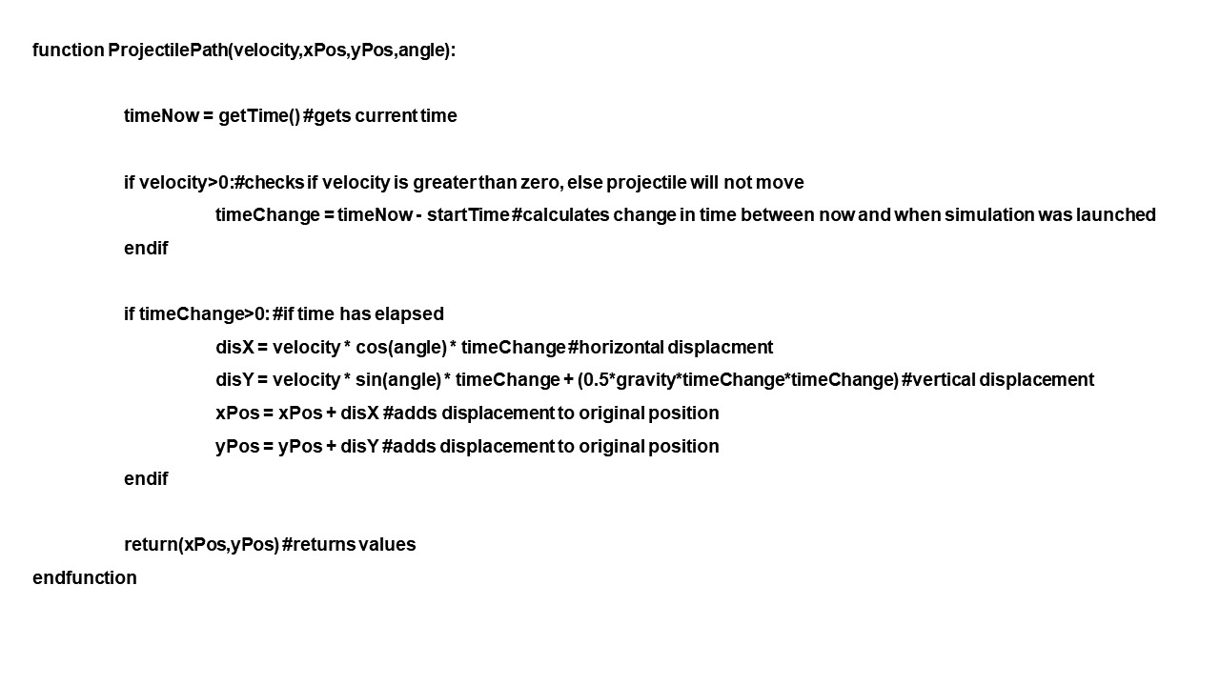
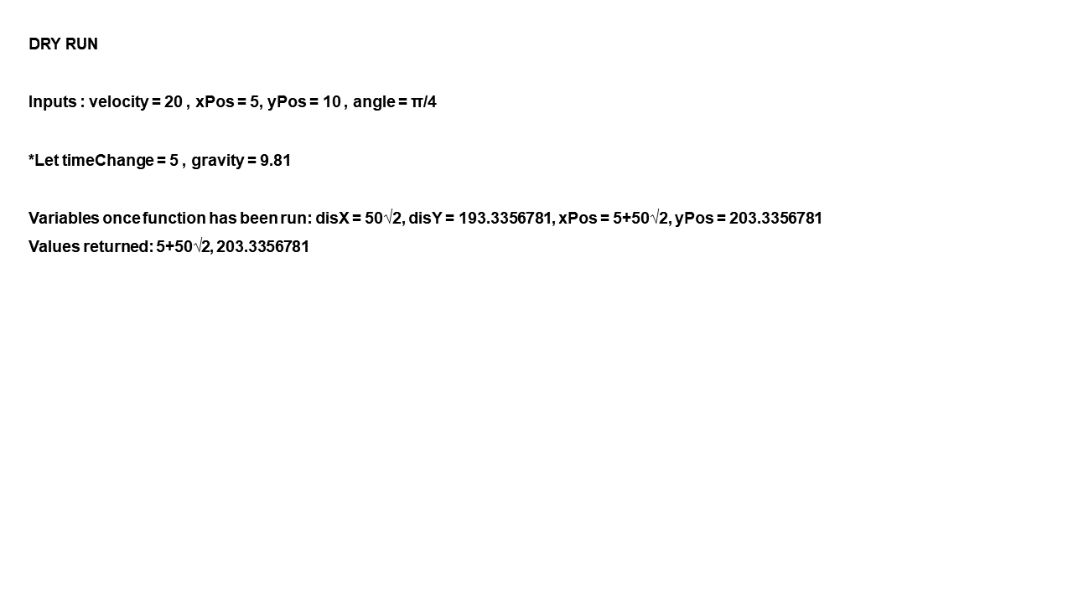

Password (Registering) validation: This algorithm will check if the password the user has chosen meets all necessary criteria.
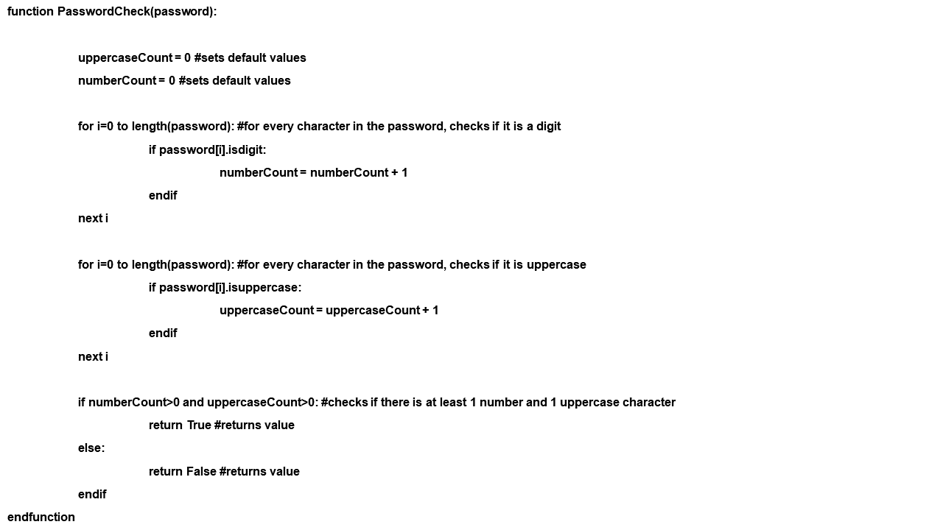

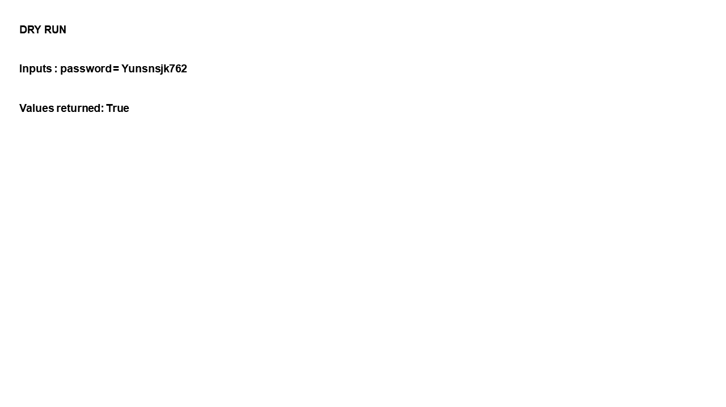

Projectile vs target: This algorithm will check if the projectile has hit the target.
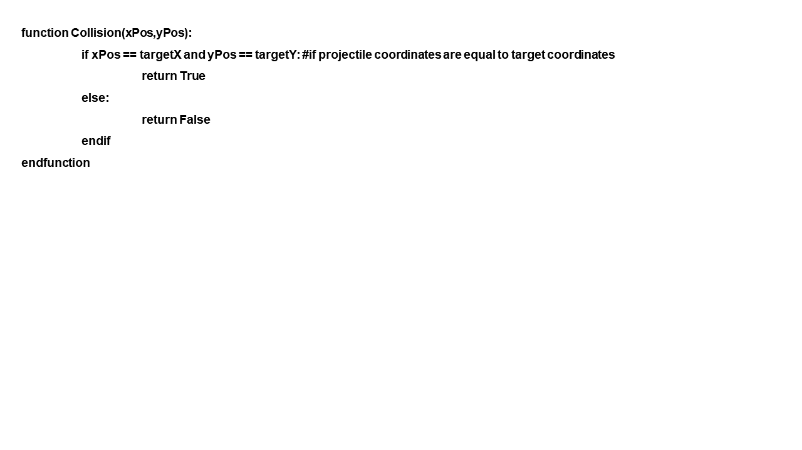
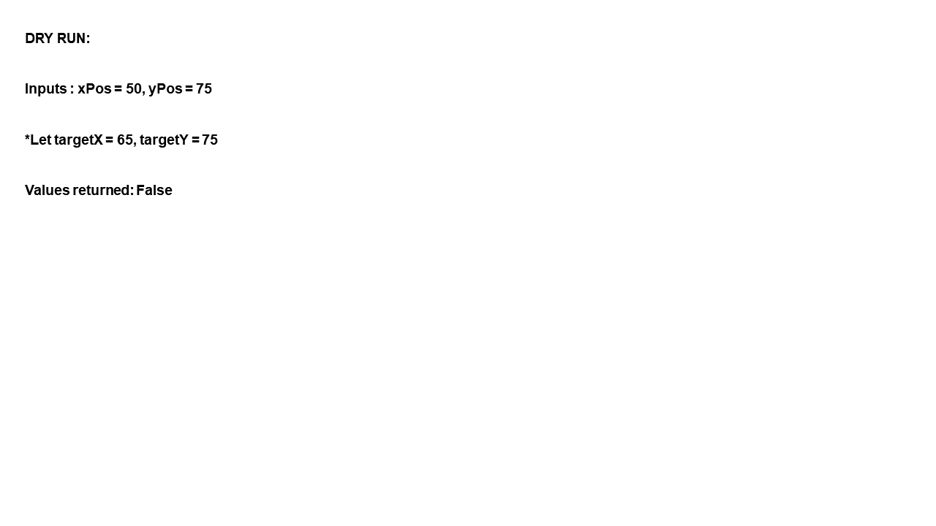

On the screen: This algorithm will check if the projectile is still located within the game window.
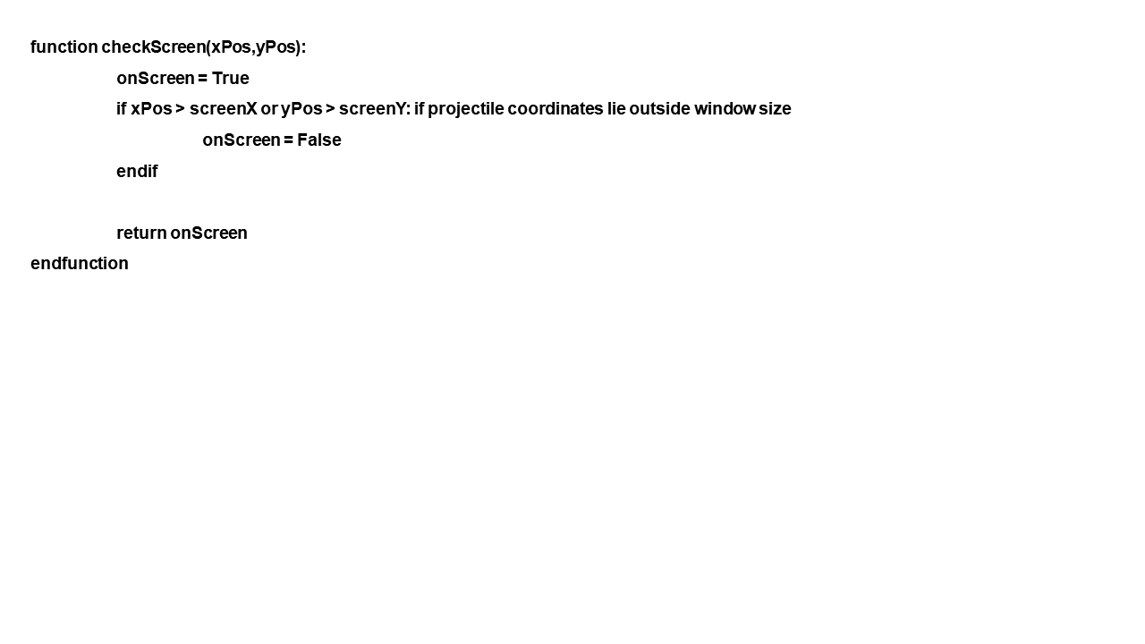
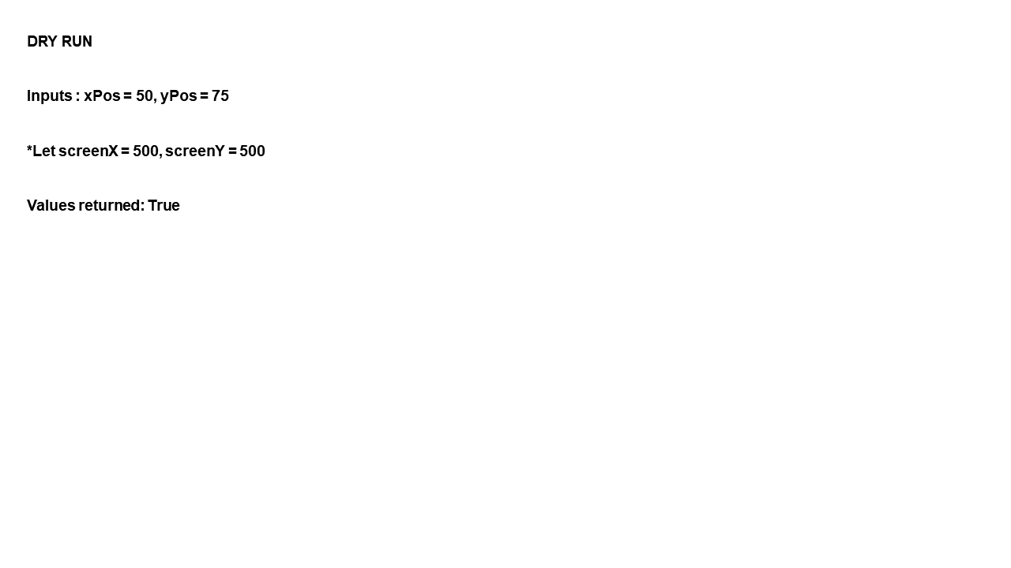

User interface design:
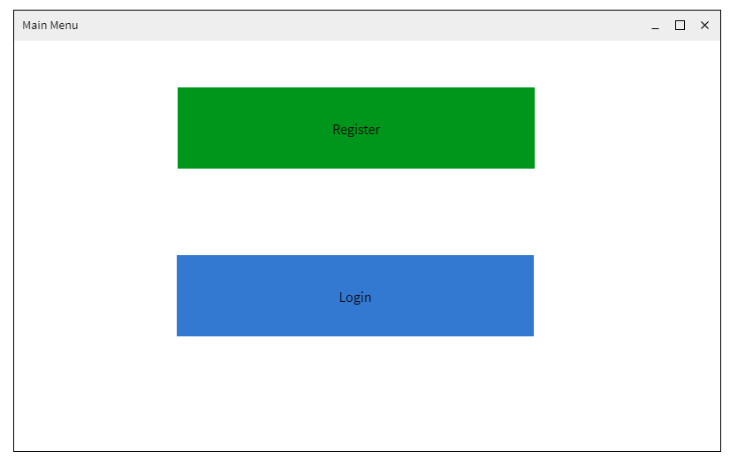This is the first screen that the user will see. It contains two buttons with options to register or to login.
Link to success criteria: A login/ registration system for users
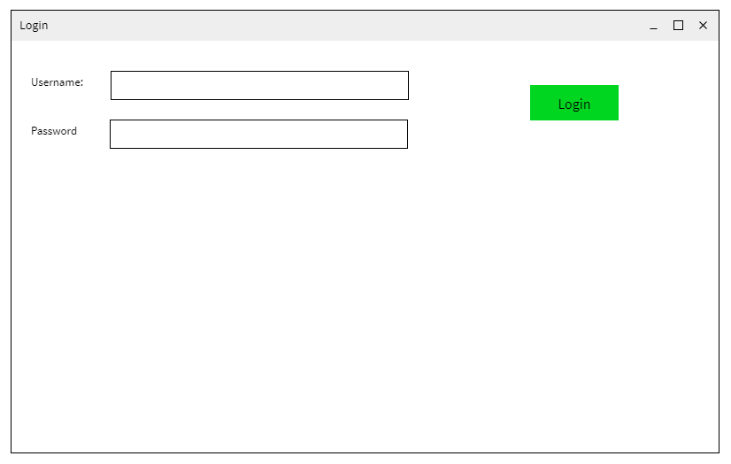
This is the screen that the user will use to login. It contains two fields to enter the username and password.
Link to success criteria: A login screen.
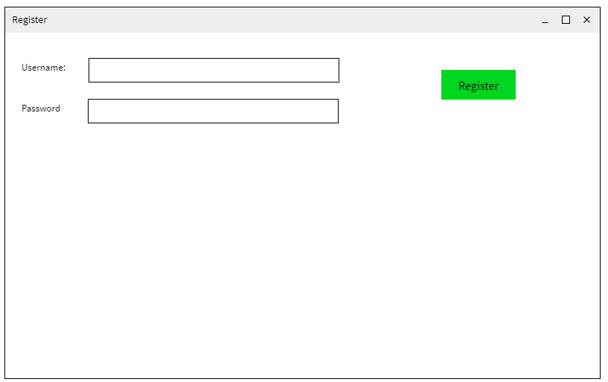
This is the screen that the user will use to register. It contains two fields to enter the username and password.
Link to success criteria: A registration screen.

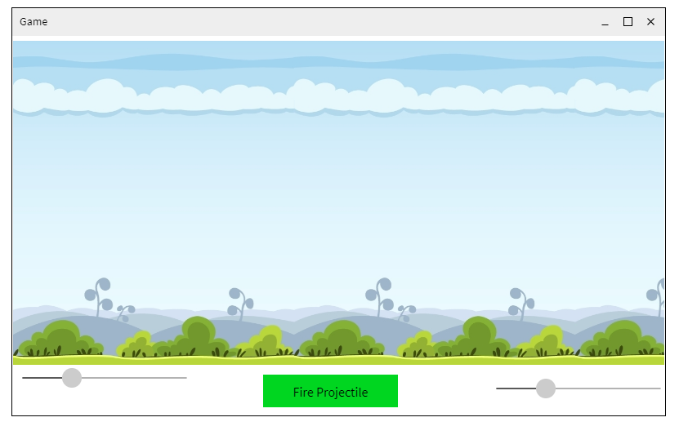
Link to success criteria: Use of slider bar system to fire projectile

Stakeholder feedback:
Make a numeric display to show the angle and initial velocity in detail (so its adjusted by the slider, but displayed clearly with the value).
Given that your login and register screens are so alike, maybe combine them into one, with both buttons available once you have entered in a valid username and password
Perhaps include a background for the login screen
Your sliders should have the same y position

Changes to user interface design (taking into account stakeholder feedback)
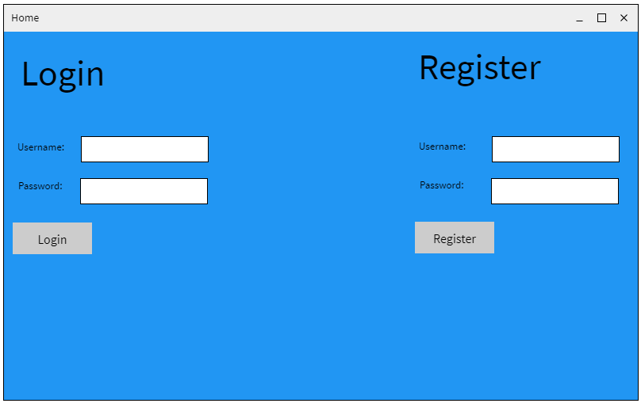
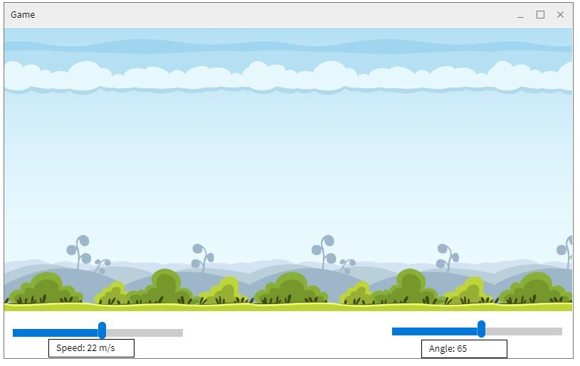
Usability features:
I have considered many usability features so that my program is easy to use.
All of the buttons on my user interface design are large. This is so that people that have difficulty with their vision can see the buttons more easily.
Large buttons
My interface design is very simple with as few buttons and text as possible. This is so that the users can easily understand the information that is presented to them. This lightweight design will improve the user’s experience
Few buttons and text
.

Key Variables:
These are the main variables that my program will use.
Variable Name | Data Type | Description / How it is used | Justification
velocity | Floating Point | To store the velocity that the user has inputted. Will be measured in metres per second. It is used in the calculations of the projectile motion. | Needed for projectile motion calculations.
xPos | Floating Point | To store the horizontal position of the projectile on the screen. It is updated with every tick of the game clock. It is used in the calculations of the projectile motion. | Needed for projectile motion calculations.
yPos | Floating Point | The store the vertical position of the projectile on the screen. It is updated with every tick of the game clock. It is used in the calculations of the projectile motion. | Needed for projectile motion calculations.
angle | Floating Point | The store the angle of the projectile (measured to the positive x-direction; measured in radians). It is used in the calculations of the projectile motion. | Needed for projectile motion calculations.
disX | Floating Point | To store the horizontal displacement of the projectile in each tick of the game clock. It is used in the calculations of the projectile motion. | Needed for projectile motion calculations.
disY | Floating Point | To store the vertical displacement of the projectile in each tick of the game clock. It is used in the calculations of the projectile motion. | Needed for projectile motion calculations.
loginUsername | String | To store the username that the user has inputted (when logging in). | Needed to implement login system
loginPassword | String | To store the password that the user has inputted (when logging in). | Needed to implement login system
registerUsername | String | To store the username that the user has inputted (when registering). | Needed to implement registration system
registerPassword | String | To store the password that the user has inputted (when registering). | Needed to implement registration system
startTime | Floating Point | To store the time of the game clock when the game was launched. | Needed for projectile motion calculations.
timeNow | Floating Point | To store the time of the game clock at a certain point. | Needed for projectile motion calculations.
timeChange | Floating Point | To store the difference between the value of ‘startTime’ and ‘timeNow’. This is then used in the calculations of the projectile motion. | Needed for projectile motion calculations.

Validation:
I will validate all user inputs to make sure that the program is robust. To do this, I will check if the data is of the correct type and size.
Initial velocity:
It must be a floating point value. It cannot be negative and cannot be zero – otherwise the projectile will not move.

Angle of release:
It must be a floating point value. It will be entered in degrees (will be converted into radians during the program. Must be between 0 and 90, measured from the positive x-direction.
Login Password:
It must be at least 8 characters in length and contain at least 1 number and 1 uppercase character.

Example validation algorithm:
function PasswordCheck(password):

uppercaseCount = 0 #sets default values
numberCount = 0 #sets default values

for i=0 to length(password): #for every character in the password, checks if it is a digit
if password[i].isdigit:
numberCount = numberCount + 1
endif
next i

for i=0 to length(password): #for every character in the password, checks if it is uppercase
if password[i].isuppercase:
uppercaseCount = uppercaseCount + 1
endif
next i

if numberCount>0 and uppercaseCount>0: #checks if there is at least 1 number and 1 uppercase character
return True #returns value
else:
return False #returns value
endif
endfunction

Buttons:
The buttons in my program will be part of Tkinter, making them robust. The buttons will not be linked directly to any functions, so there is no risk of passing incorrect data.
Sliders:
The sliders in my program will be part of Tkinter, making them robust. I will ensure that the sliders are set to have minimum and maximum values that are acceptable for the program so will not cause any errors. The sliders will not be directly linked directly to any functions, so there is no risk of passing incorrect data.

3.3.3 Describe the approach to testing

Testing:

In this section I will outline both the iterative development and post development testing.
Testing methods:
Black box: This testing is carried out independently of the code of the program. It will involve testing the inputs and outputs.
White box: This testing checks the the logic of code.
Alpha: This testing is carried out by the software developer’s testing team. As I am the sole developer, I will undertake this testing.
Beta: This testing is carried out by potential users. For this, I will get my main stakeholder, David Kuc, to undertake this testing.

Iterative development:
To complete my program, I will use iterative development. This will mean that I will decompose the problem (as explained earlier) and then solve and test each section independently. This means that after each section is developed and tested, a prototype will be created.

Main Test Plan:
Test Number | Success Criteria Reference | Description | Input(s) | Expected Output(s) | Justification
1 | 4 | User can fire the projectile using the slider bar system | Normal: e.g. velocity = 25 m/s; angle = 15 degrees  Erroneous: e.g. velocity = 0 m/s; angle = 0 degrees | Normal: Projectile is animated to move across the game screen with given velocity at at specified angle of release.  Erroneous: Displays a pop up screen saying that invalid parameters for speed and/or angle of release have been entered.
2 | 4 | Projectile motion is calculated correctly | Normal: e.g. velocity = 25 m/s; angle = 15 degrees  Erroneous: e.g. velocity = 0 m/s; angle = 0 degrees | Normal: Displacment-x = 25cos15 * time; displacement-y = 25sin15* time + 0.5 * g * t * t  Erroneous: Error message saying that the projectile motion cannot be calculated.
3 | 5 | User’s progress is saved by the game | N/A | When user loads up the game after closing it, they are taken to the right game level.
4 | 6 | User can sign up | Normal: e.g. username = mark; password = Jhnd3728df  Erroneous: e.g. username = mark ; password = dfhd | Normal: Displays a pop up screen saying that registration is complete. User is taken to the game screen.  Erroneous:  Displays a pop up screen saying that the password has not be the specified criteria.
5 | 6 | User can login | Normal: e.g. username = mark; password = Jhnd3728df  Erroneous: e.g. username = mark ; password = dfhd | Normal: Displays a pop up screen saying that the login details are correct. User taken to the game screen.  Erroneous:  Displays a pop up screen saying that login details are incorrect.
6 | 8 | Settings button loads the correct screen | N/A | Settings screen is shown.
7 | 8 | User can toggle music | Button – on/ off | Music is turned on/ off accordingly

Post development test plan

3.3 Developing the solution

Milestone 1: Development and Testing of the Login/ Registration system
In this milestone, I will the develop and test the part of my system which will allow users to register or login to their accounts. This will involve creating a user interface which allows them to do so. Additionally, the interface will be linked to a database, which will store user information.
I first developed the home screen which is what users will first see. It contains the login and register entry spaces.
#main menu screen
def home():
#window setup
window = Tk()
window.title("Home")
window.minsize(800,500)
window.configure(bg="#0394fc")

#top of the screen labels

loginLabel = Label(window,bg="#0394fc",text="Login",font=("",30)).place(x=20,y=20)
registerLabel = Label(window,bg="#0394fc",text="Register",font=("",30)).place(x=500,y=20)

#login labels and entries
loginUsernameLabel = Label(window,bg="#0394fc",text="Username: ").place(x=10, y=120)
loginUsernameEntry = Entry(window).place(x=80, y=120)
loginPasswordLabel = Label(window,bg="#0394fc",text="Password: ").place(x=10, y=160)
loginPasswordEntry = Entry(window).place(x=80, y=160)

#login button
loginButton = Button(window,text="Login",width="8").place(x=10, y=200)

#register labels and entries
registerUsernameLabel = Label(window,bg="#0394fc",text="Username: ").place(x=500, y=120)
registerUsernameEntry = Entry(window).place(x=570, y=120)
registerPasswordLabel = Label(window,bg="#0394fc",text="Password: ").place(x=500, y=160)
registerPasswordEntry = Entry(window).place(x=570, y=160)

#register button
registerButton = Button(window,text="Register",width="8").place(x=500, y=200)

window.mainloop()

home()

The login and register entry spaces were implemented on the same screen because my stakeholder requested this as part of his feedback on my user interface design prototyping. Therefore, this code doesn’t strictly match the decomposition in the design section where I previously split up the login and register entry spaces.
This is how the home screen looks. As seen below, it closely resembles the prototype that I developed as part of the design section.
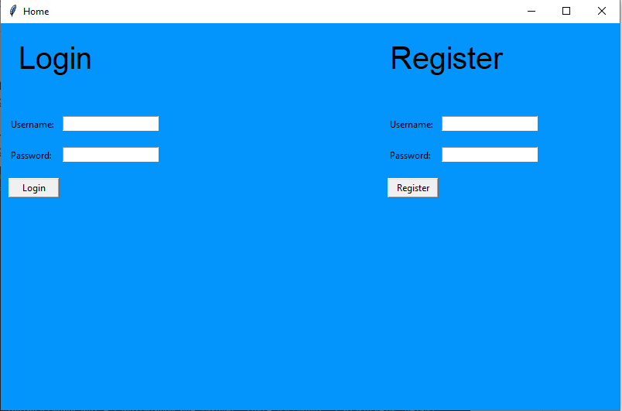
Having created the interface for the user to register or login, I now developed a database which would connect to the program and store user information. When users logged in, the information they entered would have to match the information that was stored in the database when they registered.
To develop my database, I will use SQLite.
After initialising my database, I created a table which will store the username and password of users.
#procedure to create table in my database
def createTable():
conn = sqlite3.connect('ProjectileMotionGame.db') #connects to database
c = conn.cursor() #cursor class allows you to invoke methods that execute sqlite statements
#table is created with username and password fields
c.execute("""CREATE TABLE users(
username text,
password text
)""")
conn.commit()
conn.close()

Now, I needed to link the entry boxes to the database so that user information could be stored and queried from it.
At first, I had some problems with implementing this. For example, what was entered wouldn’t be passed on into the required function. Instead, “None” would be passed.
To fix this, I had to make these variables global so that they could be accessed by any function.

